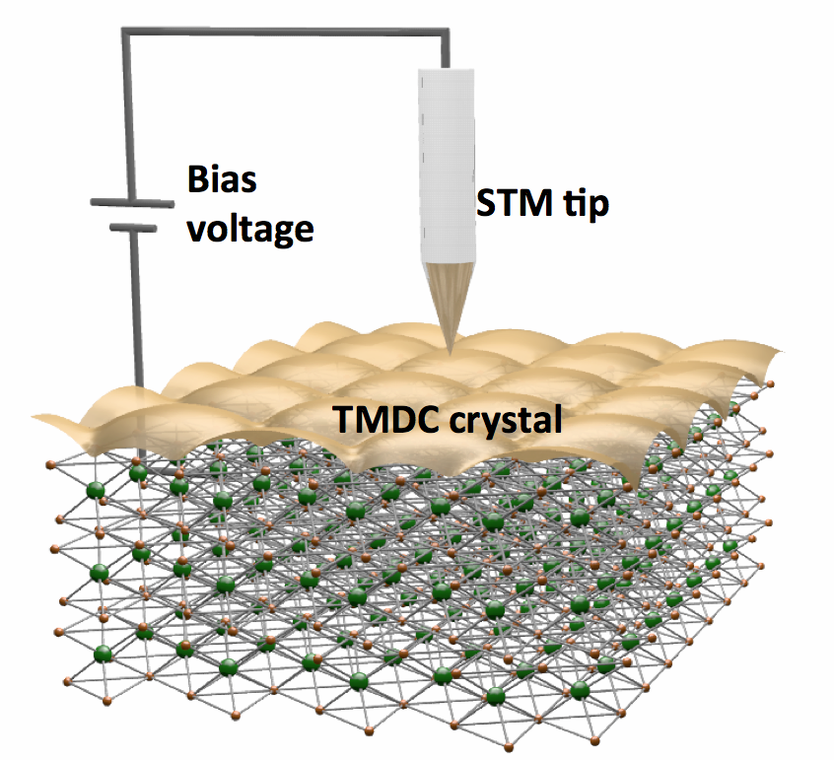
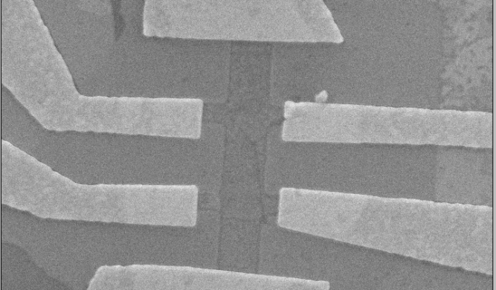
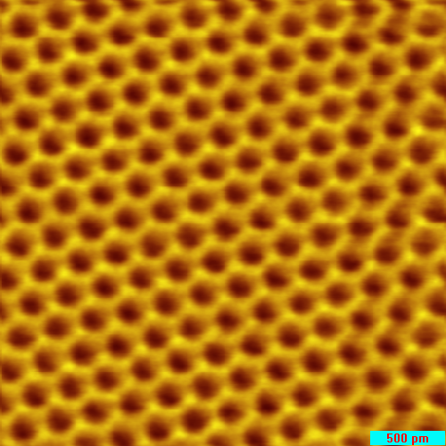
Special topics in condensed matter physics: Low-dimensional materials and their characterization by imaging techniques
Tentative topics outline
- Review of solid state concepts: free electrons in solids, electronic band structure, motion of electrons and transport phenomena
- Nanostructures: 0D systems, 1D systems
- Surfaces and Interfaces, 2D systems, Quantum Hall effect
- Graphene
- Beyond graphene: semiconducting TMDCs, metallic TMDCs
- Imaging techniques for nanostructures (atomic force microscopy and variations, scanning tunneling microscopy, etc.)
- Scanning tunneling microscopy and spectroscopy – basic theory
- Scanning tunneling microscopy and spectroscopy – history and experimental details
- Journal club: Imaging techniques used to understand low dimensional systems

Reference texts
Throughout the course we will use a combination of journal articles and textbooks (some of them listed below)
- The Oxford Master Series in Physics, Solid State Physics by N. W. Ashcroft and N. D. Mermin Introduction to Solid State Physics by C. Kittel
- S. Datta, "Electronic transport in mesoscopic systems", (Cambridge U. Press 1997).
- Physics of Graphene, Editors: Aoki, Hideo, S. Dresselhaus, Mildred (Eds.) (2014)
- C.J. Chen. Introduction to scanning tunneling microscopy, volume 4. Oxford University Press, USA, 1993.
- J.A. Stroscio and W.J. Kaiser. Scanning tunneling microscopy, volume 27. Academic Pr, 1993.
- R. Wiesendanger. Scanning probe microscopy and spectroscopy: methods and applications. Cambridge Univ Pr, 1994.

Assessment
- Take home exercises (40%)
- Final project (60%) - journal club style presentation on a chosen topic

Scanning Tunneling Microscopy (STM)
Scope of the course
Spatially restricting the motion of electrons in a material can give rise to some of the most fascinating physical phenomena seen in all of condensed matter physics and they represent the working principles of many modern technologies.
This course will provide an introduction to the physics of low-dimensional materials and their characterization using imaging techniques. Starting from the basic properties of electrons in confined systems, we will then focus specifically on recent research on graphene and other layered transition metal dichalcogenides (TMDCs). One of the most direct and powerful experimental techniques used to characterize the structure and electronic properties of this class of materials is scanning probe microscopy. In this course, we describe the basic principles of operation of this technique and then discuss how such experiments advance our knowledge of material properties in low dimensions.

A graphene transistor
Carbon atoms in the graphene lattice imaged
with an STM
Adina Luican-Mayer (adinaluican@gmail.com)

